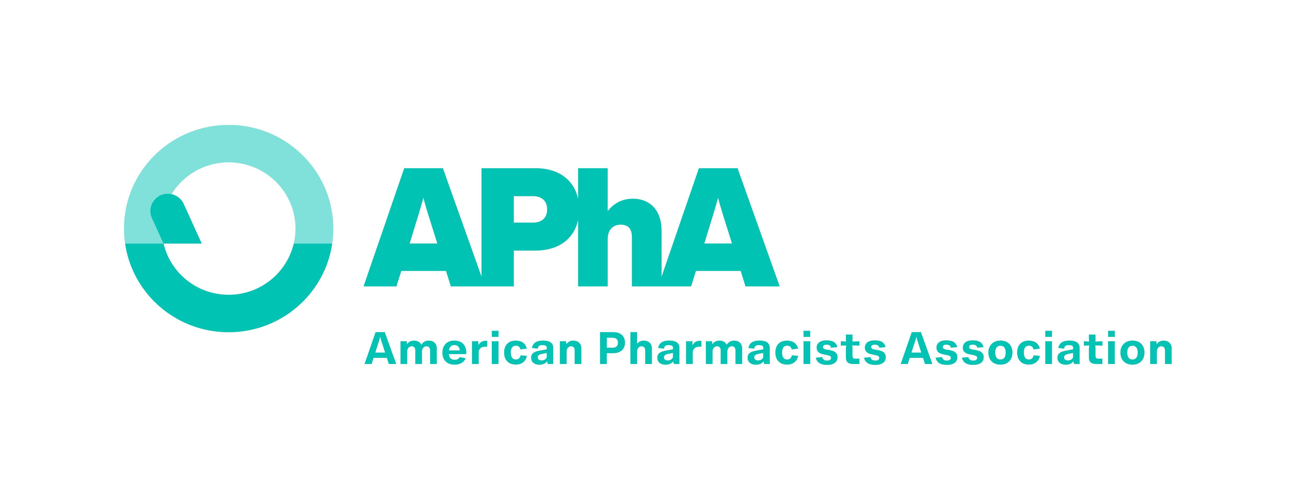
APhA Academy of Student Pharmacists
Regional Officer Application

CANDIDATE STATEMENT OF CONSENT

As an applicant for APhA-ASP Regional Office, I agree to uphold the following statements:

- I am aware of the responsibilities, meetings, and travel requirements outlined for the APhA-ASP position to which I am seeking.

- If elected, and I find that I am unable to fulfill the duties for that position, I understand that APhA has the authority to replace me with a qualified candidate.

- If elected, I agree to serve APhA and APhA-ASP to the best of my ability and to the best of my knowledge.

- If elected, I agree to serve APhA and APhA-ASP with sound moral, ethical, and professional judgment and understand that APhA may remove me from my office if my actions violate sound moral, ethical, and professional judgment.

- If elected, I understand that upon the discretion of APhA, I may have to resign from any local, regional, national, or international positions held in APhA-ASP or any other pharmacy and non-pharmacy associations, clubs, or organizations.

- I have read, understand, and will comply with the APhA-ASP Regional Officer Election Regulations and Procedures.

- I have read and understand the APhA-ASP Midyear Regional Meeting Rules of Procedure and understand the election process for the office I am seeking.

- I understand APhA will promote the election and candidates. Campaigning conducted by myself or by others on my behalf is prohibited and will result in disqualification from seeking the position.

- I am currently in good standing at my school or college of pharmacy. I understand that if elected to the position I must maintain successful academic and professional performance throughout my term in office.

- I understand that my picture, e-mail address and qualifications will be posted on the APhA-ASP website, used in APhA-ASP publications, and will be utilized during the elections process.
- I understand that APhA reserves the right, upon its discretion, to remove any elected or appointed officer from his/her position.
- I understand and am willing to participate in the required meetings for my position, which include:
  - APhA-ASP Regional Officer Welcome & Orientation – November 12,
9:00 pm – 10:00 pm ET (Virtual Meeting)
APhA-ASP Regional Officer Business Meeting – January 10-12, 2025 (Virtual Meeting)
  - APhA2025 Annual Meeting & Exposition – March 21-24, 2025 (Nashville, TN)
Complimentary registration and a $200 travel stipend will be provided.
  - APhA-ASP Midyear Region Meeting – November 7-8 (Washington, DC)
Travel, hotel, and registration will be covered by APhA.
Regional Officers are also encouraged to participate in APhA-ASP Summer Leadership Institute – July 18-20, 2025 (Washington, DC). Complimentary registration will be provided.
- I agree that all statements on this application are true. I understand that any false statements or the failure to complete this application accurately may result in my disqualification as a candidate for an APhA-ASP elected position.

Signature of Candidate: ________________________________________________

Please print name here: ________________________________________________

Date signed: ________________________________________________

